
JswpOnline.com
Expository/Informational Writing – Quick Start Guide

START AN ASSIGNMENT
- Open your browser.  - Type the following url: JswpOnline.com.  - Click <Login>. | 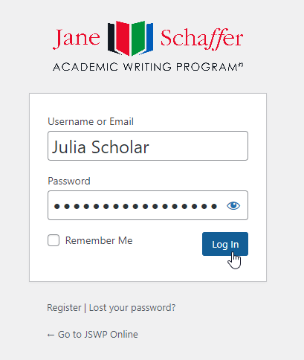
- Select the button that says, “New Assignment” or Click <New>. |   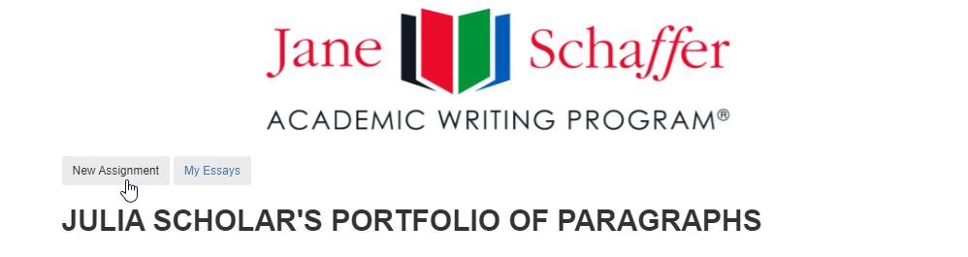
- Select the Mode of Discourse:  - Expository  - Argumentation  - Literary  - Narrative | 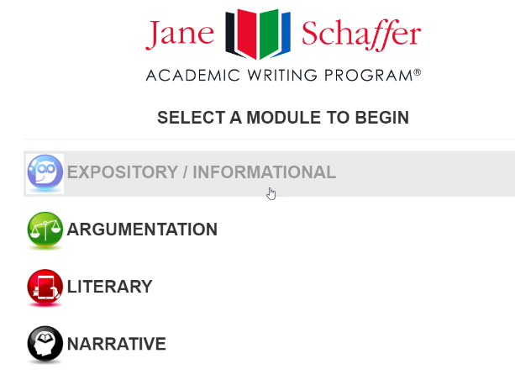

THE EXPOSITORY / INFORMATIONAL PARAGRAPH
STUDENT PORTAL
- Name Your Assignment: Staying Healthy  - Name the Course: Science  - Class Period: 1  - Due Date: 02 November 2023  - Enter Prompt: In a one-chunk expository paragraph (2+:1), discuss some effective advice you learned on staying healthy during the cold and flu season.  - Select <New Body Paragraph>.  - Name Your Body Paragraph: BP1 or BP2 or the Topic  - Determine One or Two Chunks: One Chunk  - Click <Save and Next>. | 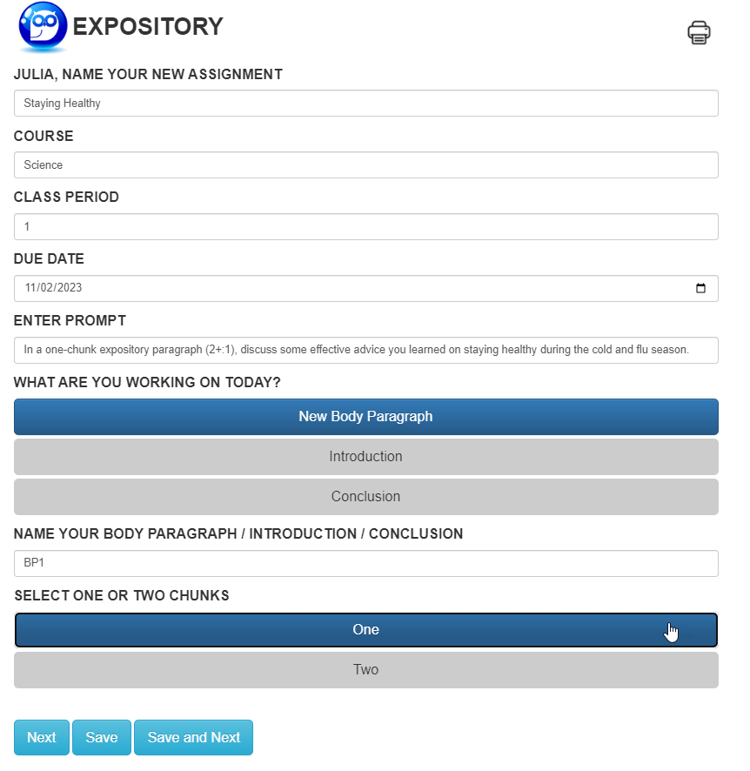
STEP ONE:  GATHERING CDS  - LIST AND ADD 3-5 concrete details (CDs), but you may also add as many as you like. You may click <Add CD> or touch “Enter” on the keyboard to add CDs.  - HIGHLIGHT the two or more lines of CDs that you want to use for your chunk. Remember, for expository (nonliterary), the ratio is 2+:1, so this step helps you choose your CDs.  - The red buttons allow you to drag and drop CDs in the order you would like them to appear.  - PRINT and/or CLICK <Save and Next>. | 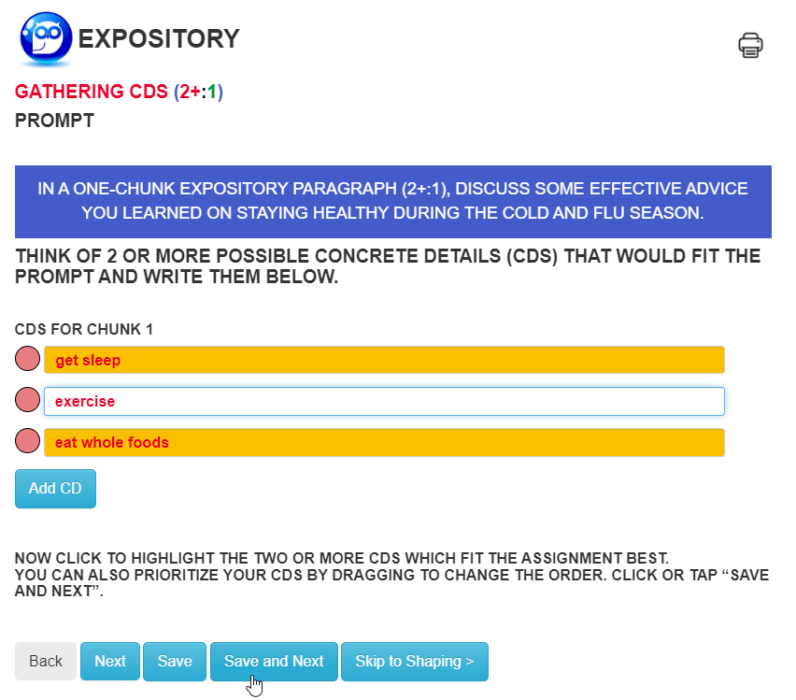

STEP TWO:  WORKING TOPIC SENTENCE  - REVIEW the writing prompt.  - TURN the prompt around to compose a “working topic sentence.”  - After you type several characters, you’ll notice that the CDs you selected on the previous page populate in the order you chose. | 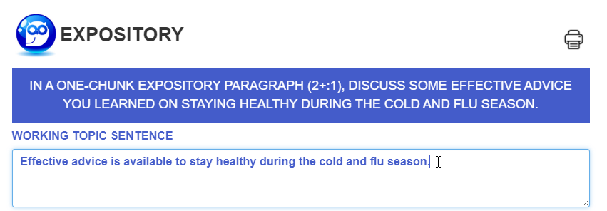
STEP THREE:  COMMENTARY DEVELOPMENT  - REVIEW your first CD. ASK YOURSELF, “Why is this important?”  - BRAINSTORM your ideas, starting with the middle oval.  CONTINUE BRAINSTORMING. You must provide at least three commentary (CM) ideas.  - REVIEW your second CD. FOLLOW STEPS #2-4 above to generate commentary ideas for your second CD.  Note: the auto-fill is for 3+:0.  - PRINT and/or CLICK <Save and Next>. | 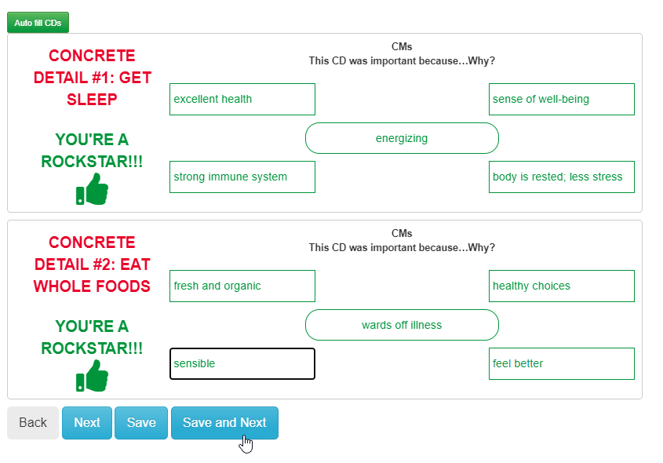
REVISE TOPIC SENTENCE  - REVIEW your CM choices and ask yourself, “How do I want to revise my topic sentence (TS)”?  - HIGHLIGHT the words and phrases that you will use to revise your TS. Remember, “once you use it, you lose it!”  - REVIEW THE REMAINING CM choices and SELECT words and phrases to write your commentary (CM) sentence.  - REVIEW THE REMAINING CM choices and SELECT words and phrases to write your concluding sentence (CS).  - CLICK <Save and Next>.  (Notice the subject/verb agreement error – “leads” vs. “lead.” We did that on purpose to show you that we proof, edit, and revise on the shaping sheet!)  STEP FOUR:  THE SHAPING SHEET  PROOF, EDIT, AND REVISE your topic sentence (TS). Our original TS had a “to be” verb. Action verbs give more information and have more of an impact. One way to rid your sentence of a “to be” verb is to invert the sentence.  We now need to write our concrete detail sentences. Use a transition when moving from the first CD to the second one. Here, we use “in addition.”  We liked our commentary sentence (CM), but we realized that in our original concluding sentence, we were repeating “these” and “actions;” so, we’re going to make some changes.  We revise our concluding sentence (CS) to avoid the repetitive words we mentioned above. Also, we fix the subject/verb agreement error from “leads” to “lead.”  Click <Save and Next.>  FINAL DRAFT | 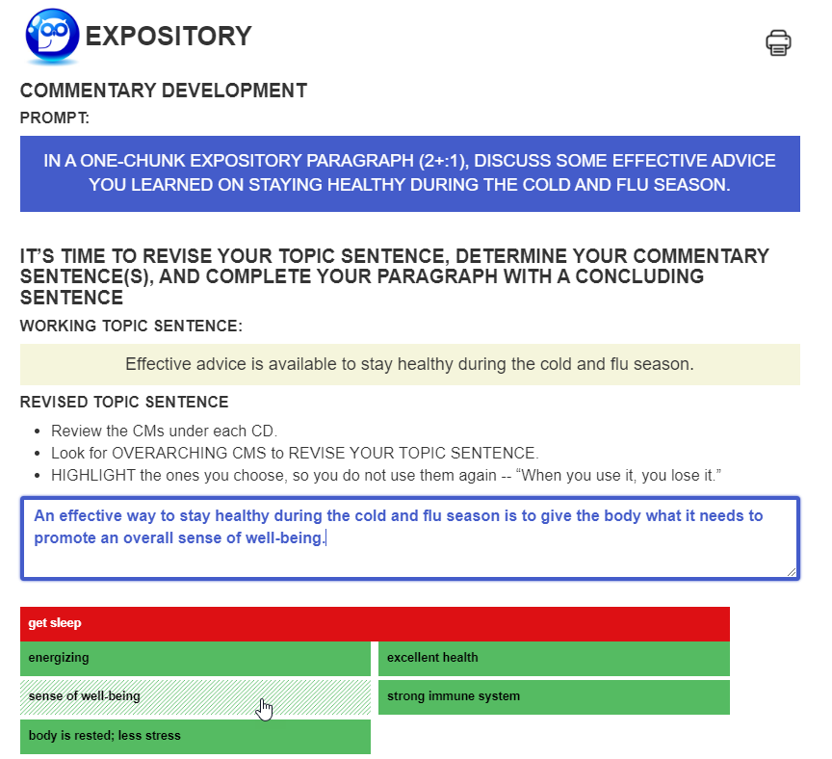  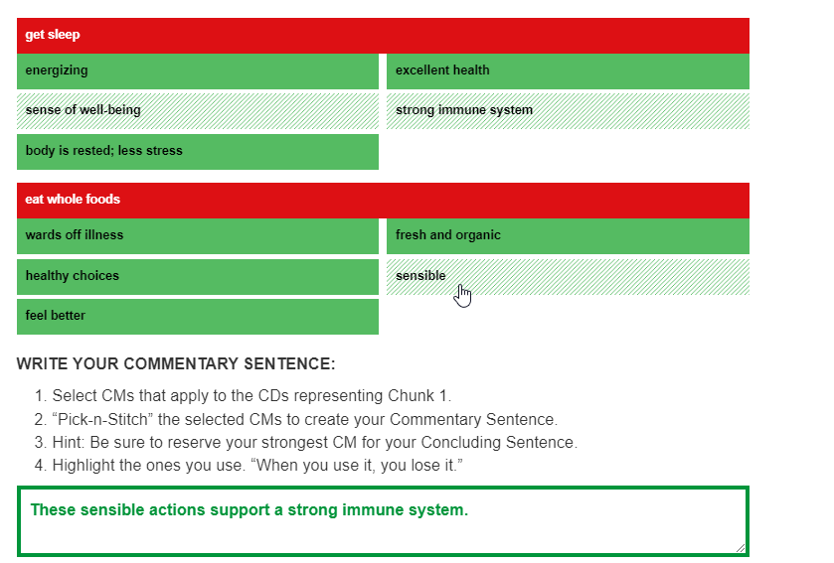  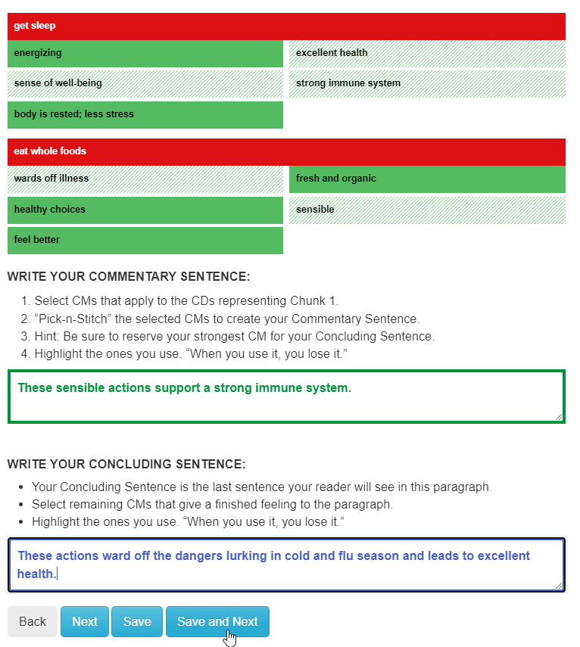  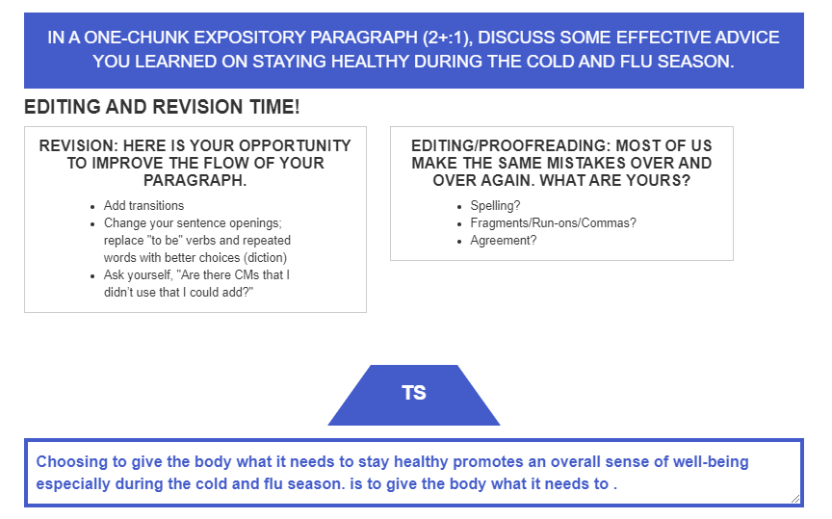  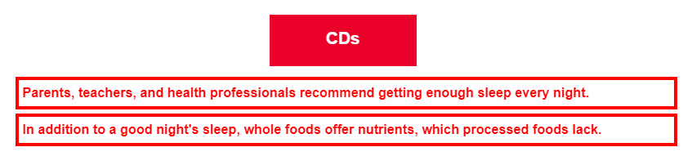  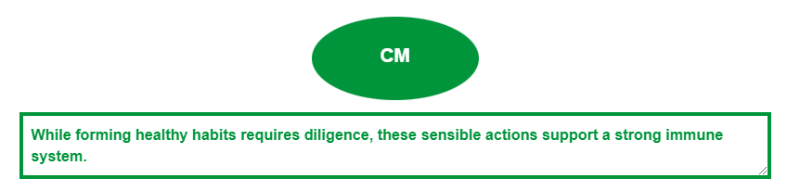  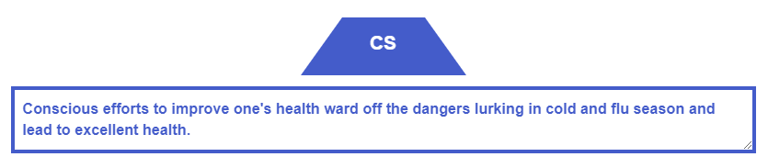  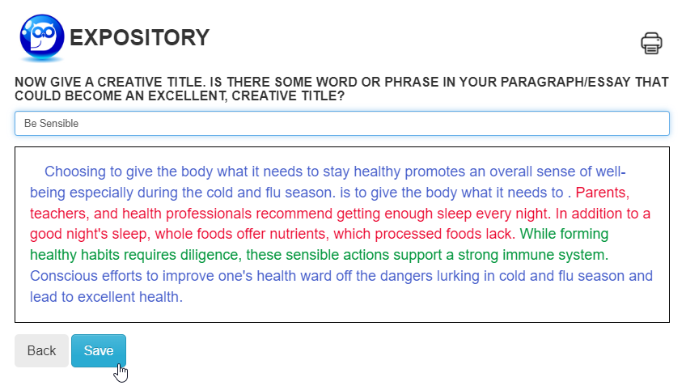  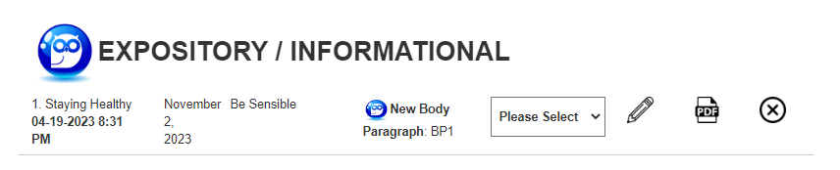

WRITING THE FIRST DRAFT  “PICK-N-STITCH”  - REVIEW your CM choices and ask yourself, “How do I want to revise my topic sentence (TS)”?  - HIGHLIGHT the words and phrases that you will use to revise your TS. Remember, “once you use it, you lose it!”  - REVIEW THE REMAINING CM choices that you will use to analyze your CD choice.  - SELECT and HIGHLIGHT words and phrases to compose your two commentary (CM) sentences. |  | 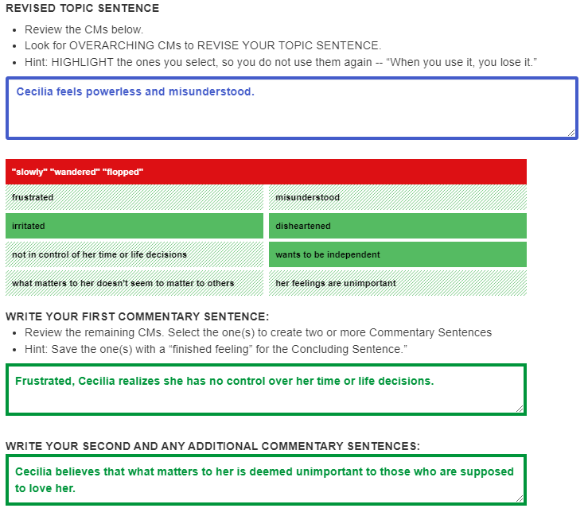
- For your Concluding Sentence (CS), write the most important word from your original or revised Topic Sentence, “Cecilia feels powerless.”  - Write synonyms and phrases that describe and go deeper for that middle word.  - Now, “pick-n-stitch” together the words and phrases to compose your CS. |  | 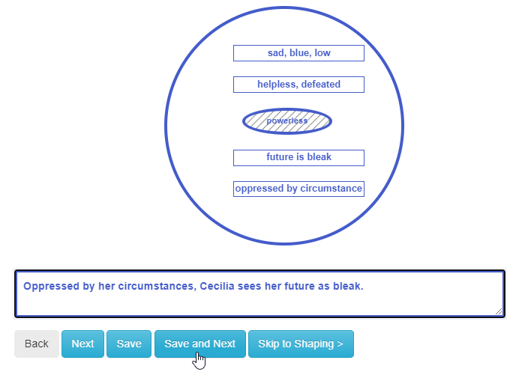
The Shaping Sheet: Revising, Editing, and Proofing to Produce a Second Draft  - Revising, editing, and proofing is the final step before your final draft.  - For the TS, notice how we added the author’s name, the title of the short story. We answered the prompt and situated the answer by telling the reader this is how Cecilia feels at the beginning of the story.  - For the CD, we embedded “slowly,” “wandered,” and “flopped,” into a sentence by starting with a ”lead-in,” paraphrasing what was happening right before. Notice how we revised the quotations into the literary present tense.  - For the first CM, we didn’t want to keep repeating “Cecilia,” so we described her – this teenager. We also placed “her” in front of “time” and “life’s decisions.”  - For the second CM, we decided we could start with a noun clause instead of repeating her name again.  - We kept the TS the same. We liked it as is.  - Click <Save and Next.> |  |  |  | 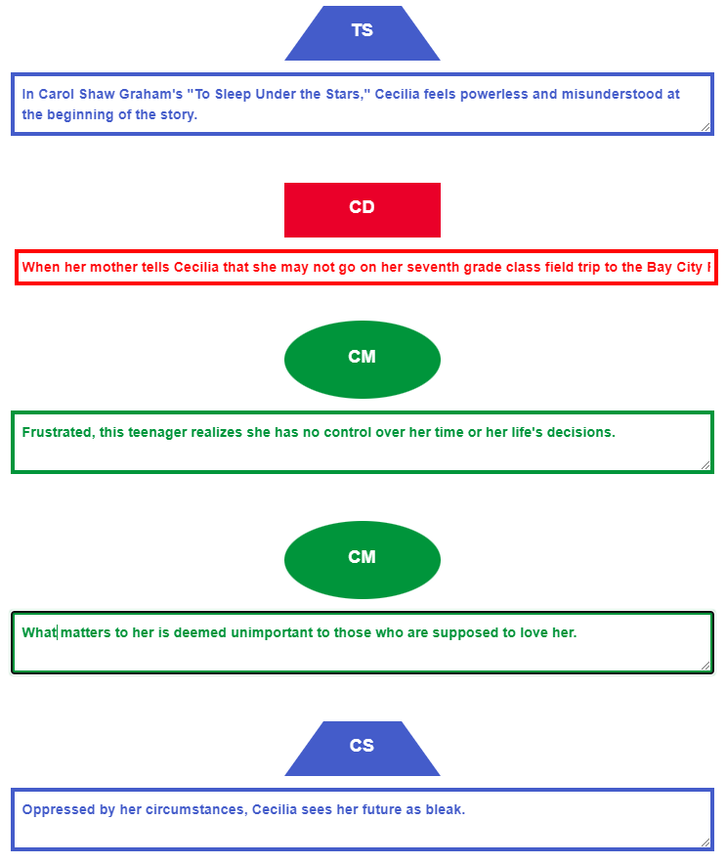
- Here is our finished product but wait. We need a title.  - We like to find a phrase in the writing that pops. We chose A Bleak Future for our title.  - Click <Save.> |  | 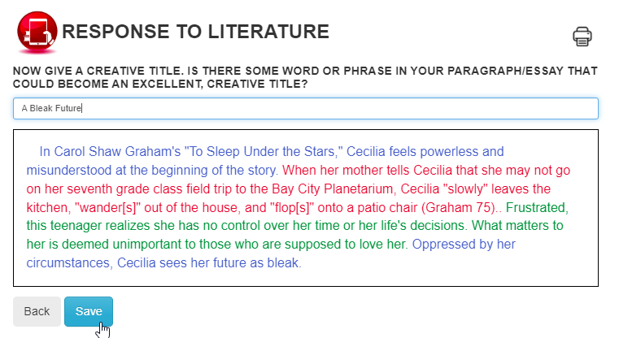
Student / Teacher Interaction: Submitting Assignments and Receiving Feedback
Return to your portfolio and make decisions. |  |  | Due Date |  |  |  | Type and Name of Paragraph |  | Edit |  | Delete
 | 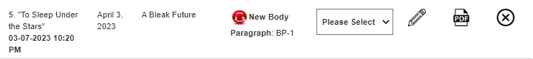
 | Assignment Title and Date Completed |  |  |  | Creative Title |  | Submit to Teacher |  |  | Create  .pdf
Submit your assignment to your teacher. Click <OK> to confirm. | 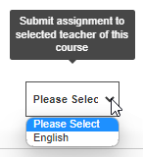
Evidence of submission. | 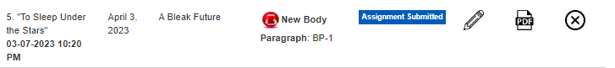

DEVELOPING AN ESSAY
- The Student is ready to build an essay.  - SELECT <Click and Stitch>. | 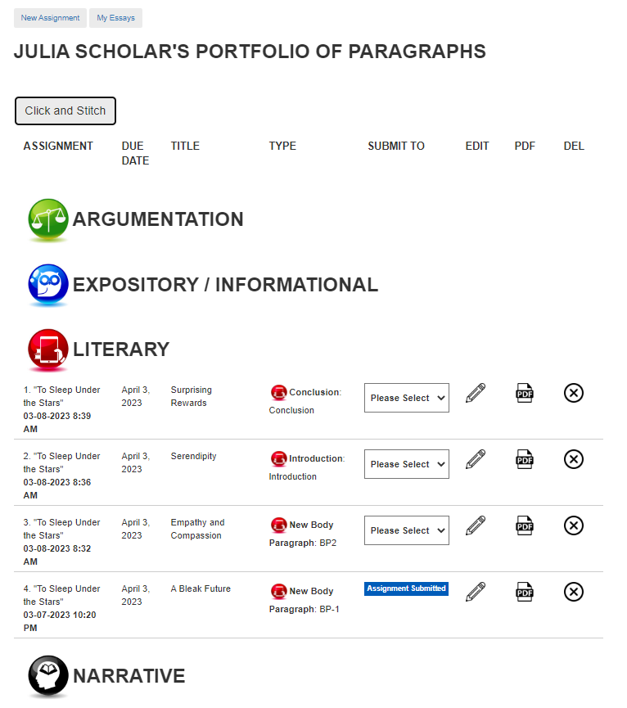
- Create a Title. Students might peruse the titles for each paragraph and select one or create a combination.  - Select the paragraphs in the order of the essay. | 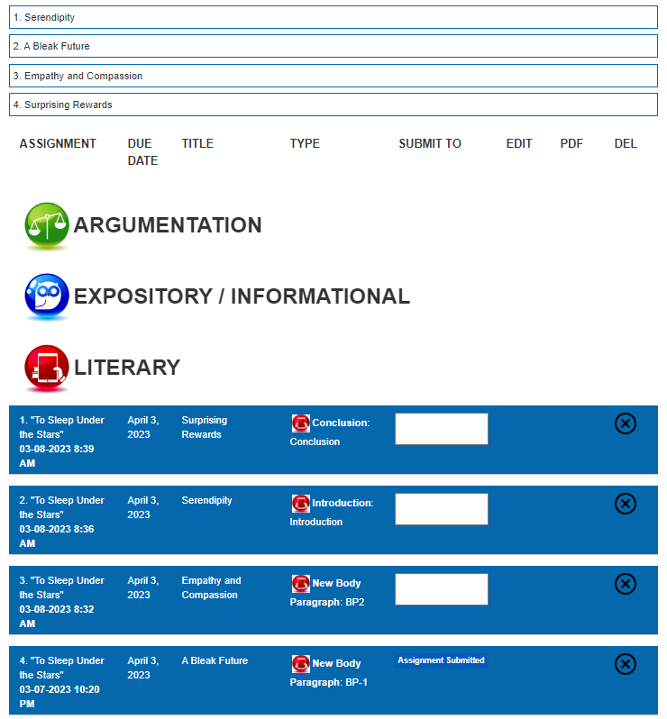
- SELECT <Build>. | 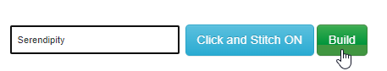

TEACHER’S PORTFOLIO
- Login  - SELECT <Submitted Assignments> | 
- Select the icon to view student work. | 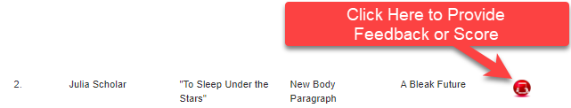
- SELECT <Click to Add Comment>.  - Read, review, provide feedback. | 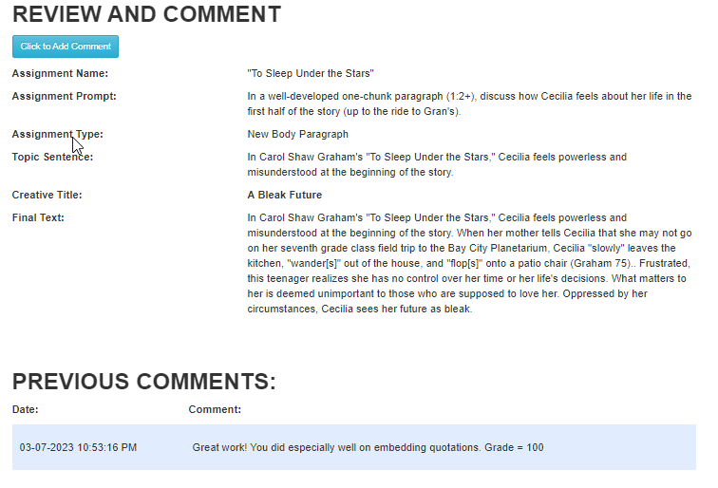
- Teachers and students may interact as many times as the teacher deems necessary. | 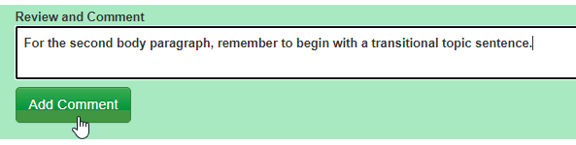
Student’s Receives a Notification after Teacher’s Feedback | 